

**JHU Homewood Campus**

**Engineering Innovation Pre-College Programs**

**Summer 2025 Commuter Handbook**

Welcome to Johns Hopkins University Homewood campus!

3400 North Charles Street  
Baltimore, MD 21218

We are delighted you will be joining us this summer!

Please review the pages that follow with your parent(s)/guardian(s), as you will find helpful information.

**Please know that Johns Hopkins Explore Engineering Pre-College Programs’ reserves the right to make changes to the following policies, rules, and regulations before or during the program.** We will provide updates via email as necessary, so watch your inbox for notices from us.

If you have questions, please contact the Johns Hopkins Explore Engineering Pre-College Programs office at 443-927-1986 or at [ei@jhu.edu](mailto:ei@jhu.edu)

# Important Dates and Times

Please be prepared to participate in the entirety of the program, Mon - Fri, 9 a.m. - 3 p.m., June 30 – July 25. There is no class on Friday, July 4.

**First Day:** All Engineering Innovation students will meet at 8:45 a.m. in Hodson 110.

**Final Day:**

Explore Engineering Innovation Students will have a Spaghetti Bridge Competition (Families may also attend): Friday, July 25 starting at 10 a.m. and will end by 12:30, with dismissal to a luncheon. More details will be sent closer to the date.

SEE: Poster presentation (Families may also attend): start at 10:30 a.m. and will end by 11:15 a.m. with dismissal to a luncheon. More details will be sent closer to the date.

# The Daily Schedule

Students will not be supervised on campus before and after their class and during their lunch period.

**Class starts:** Class starts at 9 a.m. each day. Please contact the Engineering Innovation office if you will be absent or late to class. (ei@jhu.edu or 443-927-1986)

**Lunch:** There will be an hour for lunch each day, 11:45 a.m. -12:45 p.m. All students will have lunch in either Hopkins Café or Nolan’s Café located in the Scott-Bates Commons on the corner of Charles and 33rd Streets.

**Class ends:** Students will be dismissed from class at 3 p.m..

# Directory

**Johns Hopkins Engineering Innovation Pre-College Office**  
Website: <https://ei.jhu.edu/>Address: San Martin Center, 3500 San Martin Drive, First Floor, Baltimore, MD 21218  
Phone: 443-927-1986  
Email: ei@jhu.edu

**Public Safety Office**  
Website: <https://publicsafety.jhu.edu/>Address: 3001 Remington Ave, Baltimore, MD 21211  
Emergency Phone: 410-516-7777 or 911   
Non-emergency Phone: 410-516-4600

**Student Disability Services**  
Website: <https://studentaffairs.jhu.edu/disabilities/>Phone: 410-516-4720  
Email: studentdisabilityservices@jhu.edu  
  
**Johns Hopkins University Dining Services Dietitian, Jacqueline Weiss**  
Phone: 410-516-3383  
Email: jacqueline.weiss@jhu.edu

**Sheridan Libraries**  
Website: <https://www.library.jhu.edu/>Information Desk Phone: 410-516-8335  
Email: asklib@jhu.edu  
Text the Sheridan Libraries: 410-692-8874

**Johns Hopkins Official Bookstore**  
Website: <https://johns-hopkins.bncollege.com/>Address: 3330 St. Paul Street, Baltimore, MD 21218  
Phone: 410-662-5850

**JHU Rec Center**  
Website: <https://studentaffairs.jhu.edu/recreation/>Address:3400 N Charles St, Baltimore, MD 21218  
Welcome Desk Phone: 410-516-4434  
Equipment Room Phone: 410-516-4453  
Recreation Office Phone: 410-516-5229  
Email: recreation@jhu.edu  
  
*Pre-college students will have Rec Center access:*  
*Monday – Friday: 4:00PM – 8:00PM*

*Saturday and Sunday: Noon – 3:00PM*

**International Student Services**  
Website: <https://ois.jhu.edu/>Email: ois@jhu.edu  
Regular hours of operation are Monday through Friday, 8:30am - 4:30pm. After-hours emergency number for [border emergencies](https://ois.jhu.edu/Travel_Information/Emergency%20Information/) only: 443-240-193

**Title IX Coordinator, Linda Boyd, JD**  
Website: [Office of Institutional Equity](https://oie.jhu.edu/policies-and-laws/equal-opportunity-and-title-ix-notice-for-students-faculty-staff-and-applicants/)Address: Johns Hopkins University, Wyman Park Building, Suite 515, 3400 North Charles Street, Baltimore, Maryland, 21218  
Phone: 410.516.8075  
TTY: 711, MD Relay  
Fax: 410.516.5300  
Email: titleixcoordinator@jhu.edu

**Student Health & Wellness Center**  
Website: <https://studentaffairs.jhu.edu/student-health/>Address: 1 E 31st St, Homewood Apartments N200, Baltimore, MD 21218  
Phone: 410-516-8270  
Fax: 410-516-4784  
Summer Hours  
Monday: 8:30 a.m.–5 p.m.  
Tuesday: 8:30 a.m.–5 p.m.  
Wednesday: 1 p.m.–5 p.m.  
Thursday: 1 p.m.–5 p.m.  
Friday: 8:30 a.m.–5 p.m.  
*Closed daily 12 p.m.-1 p.m.*

**Office of Multicultural Affairs**  
Address: 3003 N Charles St, Homewood Apartments, Suite 100, Baltimore, MD 21218  
Phone: 410-516-8730  
Fax: 410-516-8731  
Email: oma@jhu.edu

## **Travel to campus and parking**

Johns Hopkins Engineering Innovation Pre-College students’ families are responsible for making their own travel and/or parking arrangements.

Parking – JHU Parking Office (<https://ts.jhu.edu/Parking/>). Monthly parking passes are available to be purchased for a fee.

# COVID-19 Student Policies and Expectations

Johns Hopkins’ [**COVID-19-related policies**](https://covidinfo.jhu.edu/) are updated regularly.

The guidance below may change prior to or during the summer program, so please continue to check back for updates

#### Vaccination requirements:

#### We strongly encourage students to be fully vaccinated and have at least one COVID-19 booster prior to arrival.

#### Masking requirements:

Masking is optional in all campus, classroom, and work-related spaces; individuals may choose to continue masking. Faculty can request that students wear masks while in their classroom. We highly recommend that students bring a supply of KN-95, N-95, or KF-94 masks with them to campus in case this guidance changes at any point during the program.

We want all our students to complete their summer without becoming ill with COVID-19. We respectfully ask that students wear a mask during their travels to campus and when they are in crowded public spaces for the weeks prior to arrival.

#### Negative test prior to arrival:

At this time, we do not anticipate requiring proof of a negative COVID-19 test prior to arrival.

#### Policy:

Students and staff who test positive for COVID or have the following symptoms – chest discomfort, chills, cough, decrease in appetite, diarrhea, fatigue, fever or feeling feverish, headache, muscle or body aches, new loss of taste or smell, runny or stuffy nose, sore throat, vomiting, weakness, or wheezing – will be asked to:

* If they have symptoms: they must stay at home (commuter or staff) or isolate (residential) for at least 24 hours or until both the following are true:
  1. Their symptoms are getting better overall AND
  2. They have not had a fever (and are not using a fever-reducing medication)
  3. Wear a KN-95, N95, or KF94 mask until they have been fever-free for five days AND their symptoms have been improving for five days.
  4. Practice good hygiene by covering coughs and sneezes, washing, or sanitizing their hands often, and cleaning frequently touched surfaces.

We will work with those students who must leave campus to provide academic support and transition them to online coursework until they are cleared to return.

# What to bring

Please bring your laptop if you have one. You should also bring a pencil, pen, notebook, and calculator.

## **Sheridan Libraries**

You will have access to the JHU [Sheridan Libraries](https://www.library.jhu.edu/) online resources and to the [Milton S. Eisenhower Library](https://www.library.jhu.edu/library-hours/milton-s-eisenhower-library/) and the [Brody Learning Commons](https://www.library.jhu.edu/library-hours/brody-learning-commons/) study areas on campus. Unfortunately, you will only have access to the Milton S. Eisenhower Library until July 10th as this library will be going offline due to renovations. Besides offering a place to study and books to consult or borrow, students can print, copy, or scan documents in both facilities.

**Campus Security and Emergencies**

Please program your phone with the JHU Security emergency dispatch number: 410-516-4600. You may also download the [LiveSafe App](https://security.jhu.edu/services-for-you/livesafe-app/) for free.

The RAVE Emergency Text Message System immediately broadcasts emergency information to subscribers. In cases involving an imminent threat to safety and security including weather-related emergencies on or near the Homewood campus, the university may send text message alerts. Students must, and parents/guardians may, subscribe to Johns Hopkins Emergency Alerts for the duration of your time here. To subscribe, text JHUHomewoodAlerts to 226-787. Subscribers will receive a confirmation text message in return. To unsubscribe when you leave campus, text STOP JHUHomewoodAlerts to 226-787.

Emergency blue lights are installed around campus to get you an immediate police officer response if you are in an emergency or feel concerned for your personal safety. A map of the blue light locations is available [here](http://security.jhu.edu/_template-assets/documents/blue_light_map_locations.pdf); a copy is also included at the end of this document.

A complete list of Emergency Notification options with information about how to use them is available [here](http://security.jhu.edu/campus-security/emergency-notifications/index.html).

Campus Safety and Security provides Lost and Found services for JHU. For more information about reporting an item that you have lost, please visit the [Lost and Found page](http://security.jhu.edu/services-for-you/lost-and-found/index.html).

# JHU – Homewood Campus Map

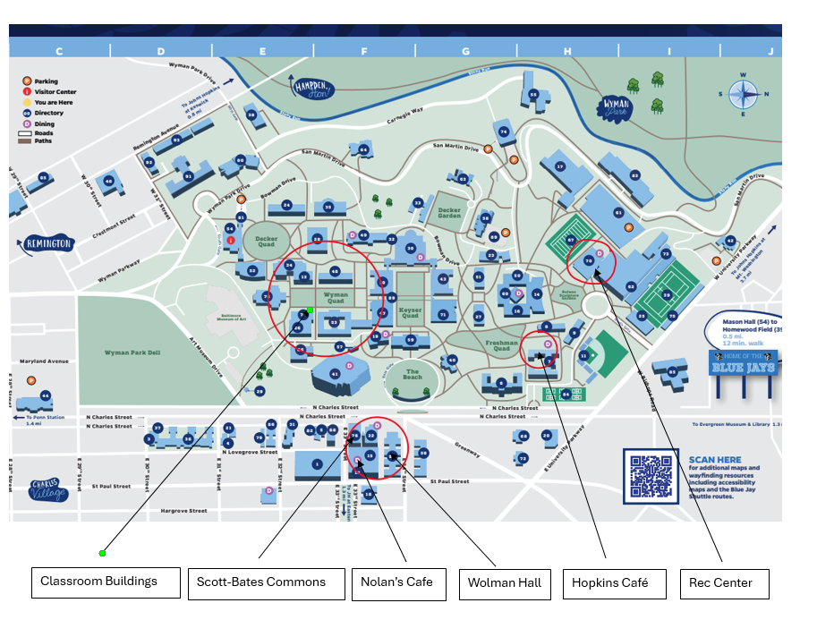

# JHU – Homewood Campus Blue Light (Security) Map

