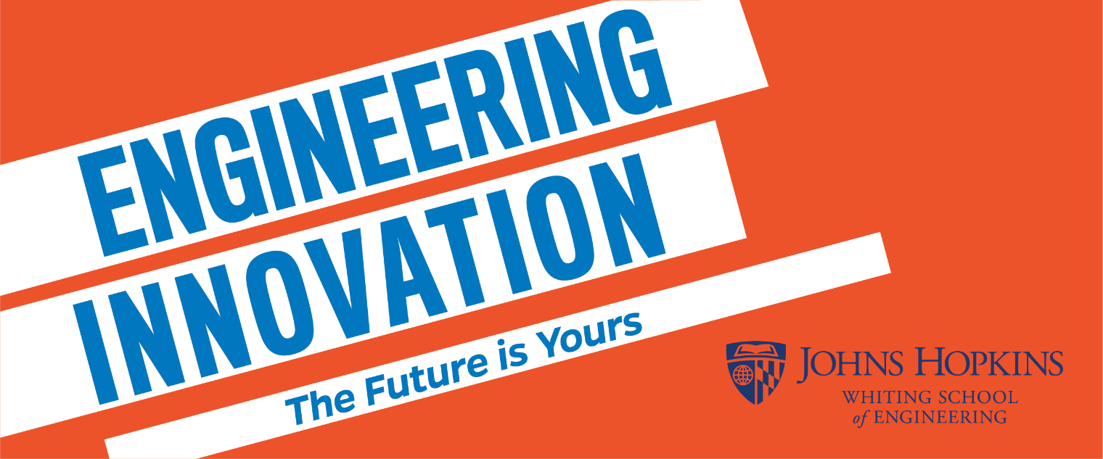
Job Description
Teaching Assistant for Sustainable Energy Engineering

Course Description:
Sustainable Energy Engineering (SEE) is a new four-week summer course for high school students who would like to learn more about sustainable energy technologies and the field of engineering. Students will either live in the residence halls or commute to campus from home. Two sections of 20-24 students each will be offered in 2023, which will serve as a pilot for expanded offerings in the future.

SEE covers a range of fundamental topics. It begins by discussing the impact of energy in our daily lives, then moves on to discuss generation, transmission, distribution, and storage. The course provides an overview of hydropower, wind, biomass, and solar energy before discussing energy use in transportation and buildings. Students also learn the basics of energy economics and planning before they complete an independent final project. The course includes hands-on lab experiments and group data analysis.

Students have the opportunity to earn three credits from Johns Hopkins University. Ultimately, the goal of the course is to expose students to engineering principles, allow them to apply the math and science they learn in high school to solving real world problems, and to help students develop critical thinking skills.

Sustainable Energy Engineering Course Dates:
In 2023, the course dates are July 3 to July 28, Monday through Friday, from 9 a.m. to 3 p.m. The course will be held in-person at the Johns Hopkins Homewood campus in Baltimore, MD and the Hood College campus in Frederick, MD.

Teaching Assistant Description:
Each class of SEE consists of 20-24 students with diverse academic backgrounds. Each class is team-taught by a PhD-level engineer and a high school teacher who teaches a STEM discipline. Select sections of SEE also have assigned to them a Teaching Assistant (TA). The role of the Teaching Assistant is to support the teaching efforts of the Instructor and Teaching Fellow.

Teaching Assistants must have knowledge of Trigonometry and Algebra 2. TAs must be punctual, have a positive attitude, and treat students with respect. They must also be able to effectively communicate both orally and in writing. A strong understanding of general engineering principles is preferred. Finally, TAs must have a positive attitude and generate enthusiasm for engineering in the classroom.
Teaching Assistant Responsibilities:
Responsibilities of Teaching Assistants include but are not limited to:
- TAs must be present and available during the entire course.
- TAs must be prepared to spend time independently to review course materials and complete the online training program prior to the first day of the course.
- TAs must work with the Instructor and Teaching Fellow to develop a sense of community for the high school students participating in this online class.
- TAs must work with the Instructor and Teaching Fellow to organize hands-on project/lab supplies so students have the materials they need for each day of class.
- TAs will assist with grading homework and other activities. They must ensure that students receive their graded assigned work promptly – within 1-2 days of the assignment due date – and provide detailed feedback to students so that they are able to learn from the activity and improve their future performance.
- TAs may be asked to hold study sessions to assist students and their understanding of lectures, labs, assignments, and projects.
- TAs must ensure that child safety protocols are upheld.

Contact:
Please contact us at ei@jhu.edu if you are interested in learning more.
