- Within an internet browser, navigate and log into the My JH Portal.
  - Note: Your username will be <your jhed@jh.edu>. Example: jsmith1@jh.edu.
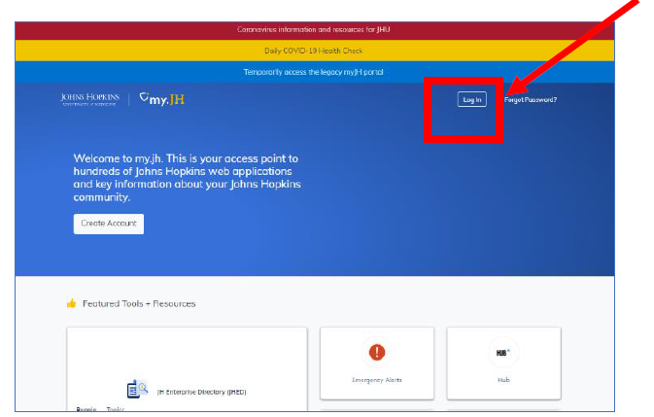

- Navigate to the upper right of the screen to the circle next to your JHED. Click on the circle and click on myProfile on the drop down menu.

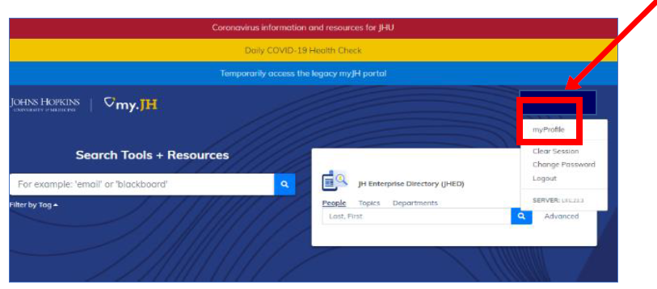
- On the myProfile page, locate the Default Email section. If unselected, choose your default email alias and then you can specify your external email address to which you want emails to be redirected. Click Save myProfile at the bottom of the page to save these changes.

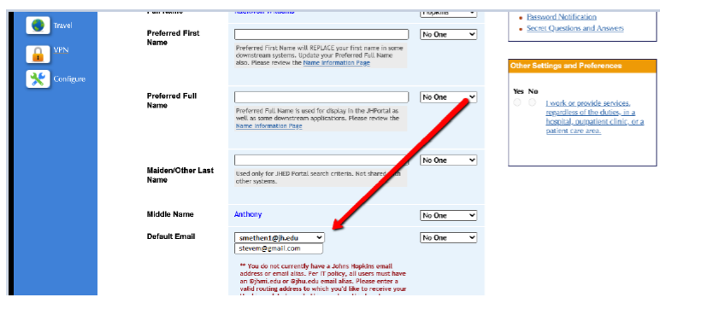

***Completed: At this point, all email that is directed to your Johns Hopkins email alias will now be redirected to your external email address. ***

Only proceed with the steps below if you are troubleshooting an issue or looking for other advanced options.

- Scroll down the page until you see Messaging and click on it.

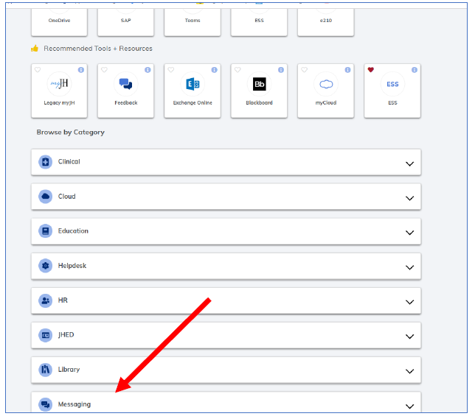

- Click on Email Alias.
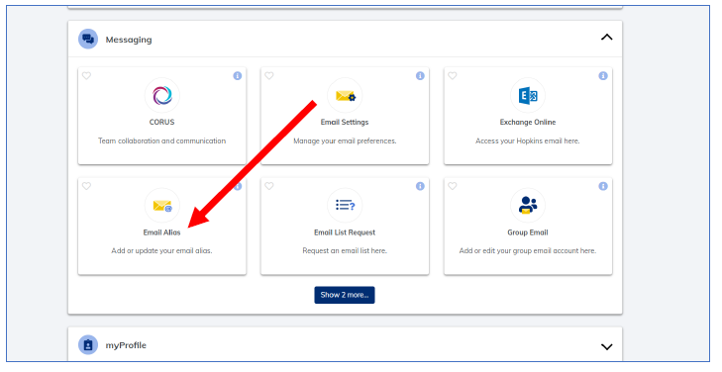
- Click the I Accept This Policy button on the JHED Email Alias Policy Form.

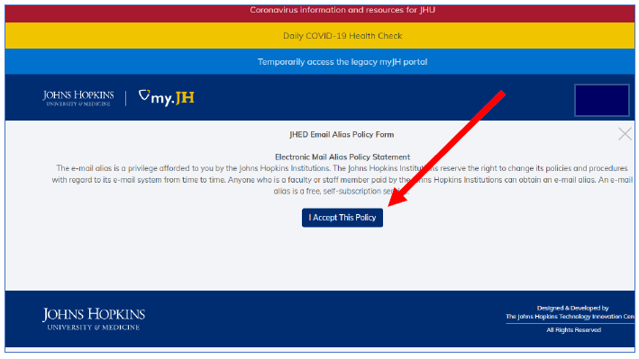

- Enter a custom address for your email aliases so that any email sent to the Johns Hopkins email aliases will be redirected to the custom address. Click update after each email alias.
  - Example: I would like all email destined to smethen1@jhu.edu and smethen1@jhmi.edu (displayed in image below) to route to stevem@gmail.com.
  - Notes: You may not be able to edit the @johnshopkins.edu or @jh.edu email alias directly from this form. Fee free to edit your common/used email aliases available to you: @jhu.edu and @jhmi.edu.
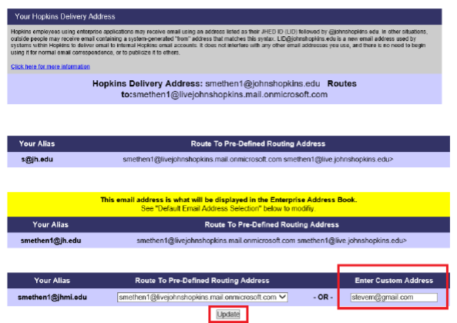

- Optional (Only if you have an existing Enterprise Mailbox) – You may need to create a forward on the mailbox via Settings through Outlook On the Web in addition to redirecting your email aliases in the My.JH portal.

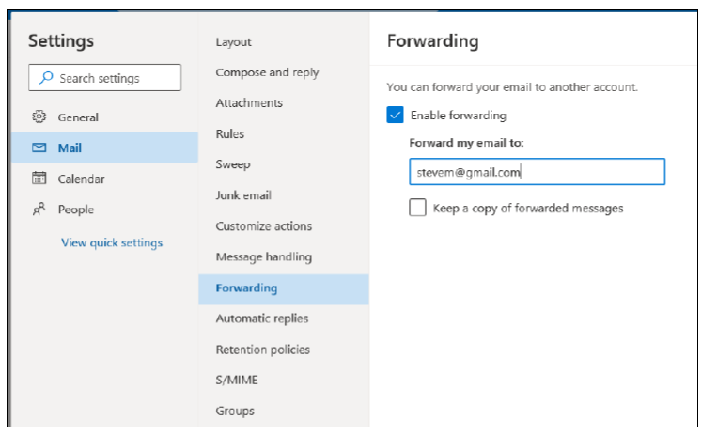

- Your common Johns Hopkins email aliases will now route to your custom address.

