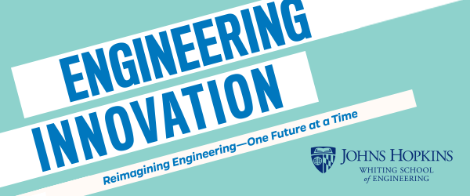
Job Description
Teaching Assistant for Explore Engineering Innovation - Online

Course Description:
EEI is a pre-college program offered by the Johns Hopkins Whiting School of Engineering and is designed to give students a significant understanding of engineering, allowing them to make informed college and career decisions.

Explore Engineering Innovation is based on an introductory engineering course taught to undeclared freshmen engineering students at JHU. EEI covers a range of fundamental engineering topics including materials science, computer science, civil, mechanical, and chemical engineering. The course includes lectures but focuses on hands-on lab experiments and group data analysis. Graded coursework includes lab reports, homework assignments, a group presentation, and a design project. Students have the opportunity to earn three credits from Johns Hopkins University. Ultimately, the goal of the course is to expose students to engineering principles, allow them to apply the math and science they learn in high school to solving real world problems, and to help students develop critical thinking skills.

Teaching Assistant Description:
Each class of EEI consists of 16-24 students with diverse academic backgrounds. Each class is team-taught by a PhD-level engineer and a high school teacher who teaches a STEM discipline. Select sections of EEI also have assigned to them a Teaching Assistant (TA). The role of the Teaching Assistant is to support the teaching efforts of the Instructor and Teaching Fellow.

TAs must have completed the Explore Engineering Innovation course (formerly called Engineering Innovation) and received a letter grade. They must have knowledge of Trigonometry, Algebra 2, and Physics. Teaching Assistants must be punctual, have a positive attitude, and treat students with respect. They must also be able to effectively communicate both orally and in writing. A strong understanding of general engineering principles is preferred. Finally, TAs must have a positive attitude and generate enthusiasm for engineering in the classroom.

Explore Engineering Innovation Online Course Dates:
In 2023, the course will be offered June 26 to July 28, Monday through Friday. Each class will meet synchronously for a single 3-hour block at the same time each day. The synchronous class meeting will occur during one of the following time intervals: 9am – noon, 2-5pm, 7pm-10pm (all Baltimore local times).

Teaching Assistant Responsibilities:
Responsibilities of Teaching Assistants include but are not limited to:
- TAs must be present and available during the entire course. This includes the daily synchronous 3-hour session as well as time to coordinate with the teaching team, grade student submissions, and hold occasional study sessions.
- TAs must be prepared to spend time independently to review course materials and complete the online training program prior to the first day of the course.
- TAs must work with the Instructor and Teaching Fellow to develop a sense of community for the high school students participating in this online class.
- TAs must be able to assist students remotely as they conduct the various activities throughout the course.
- TAs will work with the Instructor and Teaching Fellow to monitor the discussion boards and answer student messages in a timely manner, typically less than 24 hours.
- TAs will assist with grading homework and other activities. They must ensure that students receive their graded assigned work promptly – within 1-2 days of the assignment due date – and provide detailed feedback to students so that they are able to learn from the activity and improve their future performance.
- TAs may be asked to hold online study sessions to assist students and their understanding of lectures, labs, assignments, and projects.
- TAs must ensure that child safety protocols are upheld.

Contact:
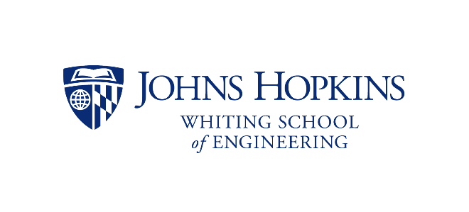
If you are interested, please email us at ei@jhu.edu. The job will be posted on the JHUJobs website, https://jobs.jhu.edu/ in early 2023.

