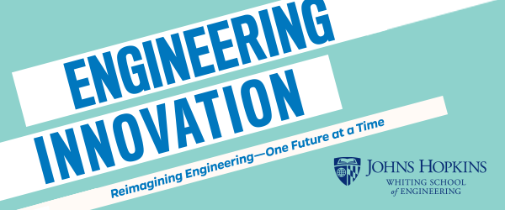
Job Description
Instructor for Explore Engineering Innovation - Online

Course Description:
EEI is a pre-college program offered by the Johns Hopkins Whiting School of Engineering and is designed to give students a significant understanding of engineering, allowing them to make informed college and career decisions.

Explore Engineering Innovation is based on an introductory engineering course taught to undeclared freshmen engineering students at JHU. EEI covers a range of fundamental engineering topics including materials science, computer science, civil, mechanical, and chemical engineering. The course includes lectures but focuses on hands-on lab experiments and group data analysis. Graded coursework includes lab reports, homework assignments, a group presentation, and a design project. Students have the opportunity to earn three credits from Johns Hopkins University. Ultimately, the goal of the course is to expose students to engineering principles, allow them to apply the math and science they learn in high school to solving real world problems, and to help students develop critical thinking skills.

Instructor Description:
We are looking for Instructors who understand, appreciate, and can apply an instructional style that emphasizes the process of problem-solving rather than memorizing material. The object is to engage students by getting them to think and participate rather than being lectured to. Each EEI class has a broad range of 16-24 students with diverse backgrounds and Instructors must be prepared to accommodate a multitude of learning styles. Finally, the Instructor must be able to engage, encourage and excite the students.

The ideal candidate will have experience teaching at the college level and a PhD in an engineering discipline that is covered in the EEI course. Substantial experience in engineering practice along with teaching is also acceptable. It should be noted that each EEI class is taught by a team comprised of an Instructor and a Teaching Fellow (TF) who is a high school math or science teacher.

Explore Engineering Innovation Online Course Dates:
In 2023, the course will be offered June 26 to July 28, Monday through Friday. Each class will meet synchronously for a single 3-hour block at the same time each day. The synchronous class meeting will occur during one of the following time intervals: 9am – noon, 2-5pm, 7pm-10pm (all Baltimore local times).

Instructor Responsibilities:
The responsibilities of each Instructor include but are not limited to:
- Instructors must be present and available during the entire course. This includes the daily synchronous 3-hour session as well as time to coordinate with the teaching team, grade student submissions, and hold occasional study sessions.
- Instructors must be prepared to spend time independently to review course materials and complete the online training program prior to the first day of the course.
- Instructors must be comfortable with the course material and be able to relate the curriculum to high school students.
- Instructors must take the lead in running the synchronous session, managing labs, and ensuring assignments are graded in a timely manner.
- Instructors must work with the TF to develop a sense of community for the high school students participating in this online class.
- Instructors must be able to assist students remotely as they conduct the various activities throughout the course.
- Instructors must work with the TF to monitor the discussion boards and answer student messages in a timely manner, typically less than 24 hours.
- Instructors must arrange for at least three study session hours each week that are hosted by one member of the team. At least one of these hours should be held by the Instructor. The study session hours should be scheduled so that all students may participate in at least one hour each week.
- Instructors and TFs must be available for supplementary instruction when requested by a student outside of the synchronous session.
- Instructors will create, as needed, additional videos to act as supplemental material to clarify/demonstrate the lab set up and/or to fill in any instructional holes that may arise.
- Instructors must ensure that students receive their graded assigned work promptly – within 1-2 days of the assignment due date – and provide detailed feedback to students so that they are able to learn from the activity and improve their future performance.
- Instructors must ensure that grades are posted to the learning management system in a timely manner.
- Instructors must ensure that child safety protocols are upheld.

Explore Engineering Innovation Instructors receive an academic appointment from Johns Hopkins University’s Academic Council and are subject to prescreening.

Contact:
Please send your CV and a 1-page teaching philosophy to ei@jhu.edu.

